Guidelines for pupils
For video calls/Googlemeet:
- Pictures or recordings of the video call are not allowed.
- Remember our school rules - they are still in place, even online.
- Set up your device in a quiet space, with no distractions in the background.
- Join the video with your microphone muted.
- Raise your hand before speaking, just like you would do in class.
- If you have the chance to talk, speak in your normal voice, using kind and friendly words.
- Show respect by listening to others while they are speaking.
- Ensure that you are dressed appropriately for the video call.
- Be on time - set a reminder if it helps.
- Enjoy! Don’t forget to wave hello to everyone when you join!
This is a working document. As we try out new ways of supporting distance learning, the document will be updated.
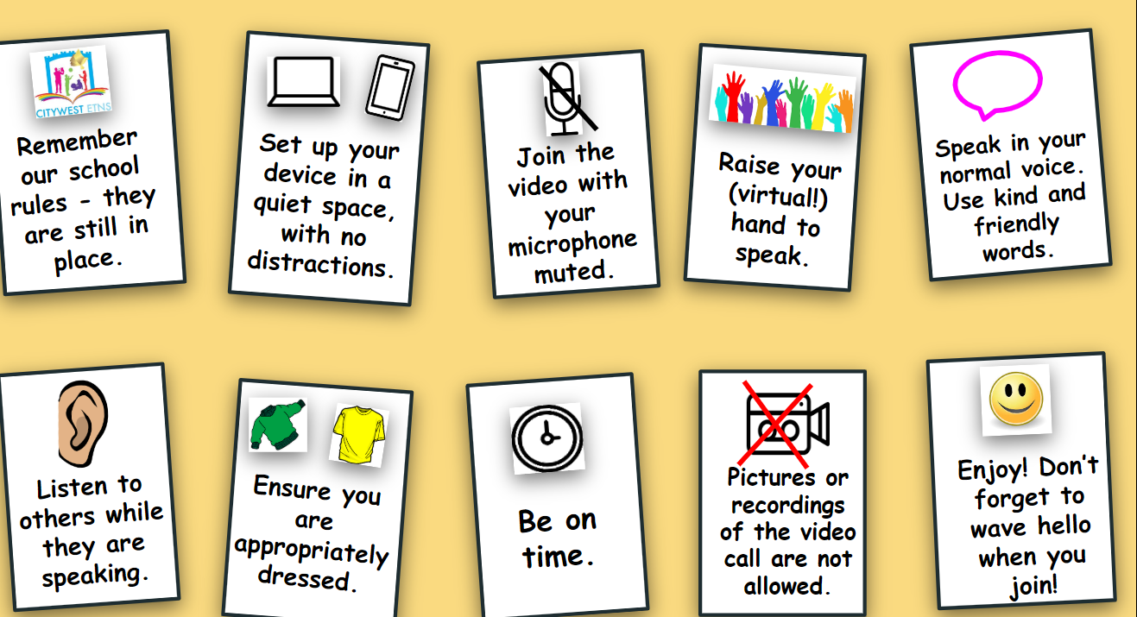

Guidelines for parents and guardians:
For video calls/Google meet
- Under no circumstances can pictures or recordings be taken of video calls.
- Ensure that the school has the correct email address for inviting you to join apps and meetings.
- The main purpose of a video call is to maintain a social connection between the school staff and pupils at this difficult time. Encourage pupils to listen and enjoy the experience.
- Be aware that when participating in group video calls, you can be seen and heard unless you are muted or have disabled your camera.
- You will automatically enter a waiting room before you are accepted.
- Please ensure that your child is on time for a scheduled video, or they may be locked out. Please request to join the call approximately five minutes before the scheduled start time. This will give school staff time to verify your email address.
- Make sure to familiarise your child with the software in advance. For video in particular, show them how to mute/unmute and turn the camera on/off.
- Participants in the call should be dressed appropriately.
- An appropriate background/room should be chosen for the video call.
It is important to note that any breach of the above guidelines will result in a discontinuation of this method of communication. A breach may also result in a person being immediately removed from a meeting or in a meeting being immediately terminated. In this case, the child’s parent will receive a report on the incident.
​

