Parents’ Guide to Afterschool Activities

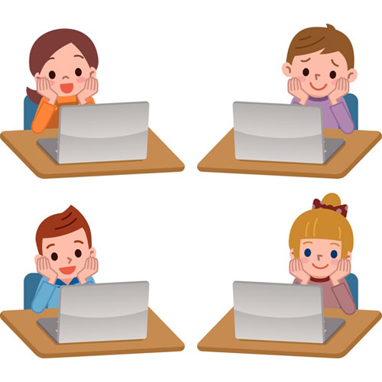

Brief outline of Rules for Afterschool Activities (also known as Afterschool Classes)

- Bookings can only be made online via the school website
- Booking usually opens on a Wednesday Evening @ 7pm and usually closes the following Tuesday at 7pm. Notes home will give exact dates and times each term.
- All cash / cheques to be delivered into the school no later than the day after the online booking period closes.
- All cash / cheques to be put into an envelope with the child’s name, afterschool activity(ies) booked, reference number and parent’s phone number written clearly on the front.
- No refund will be given once booking has closed.
- If a class must be cancelled, by the Afterschhool Comittee, an alternative class wil be offered. If no alternative class is suitable a refund will be offered at this point. If an alternative class has been accepted no refund will be given.

The Website
There is huge demand for our Afterschool classes, and as such, once they go live on the school website it can be difficult to log on due to the volume of people accessing the site at the same time. While we make every effort to ensure this doesn’t happen - you may need to keep refreshing the site in order to get access.
In the unfortunate event you do not get to book the activity your child want please send the details of the activity to the PA email or PM the facebook page. Your child will then be put on a waiting / cancellation list, and should a place become available one of the Afterschool committee will contact you.
If there is enough extra interest we will try to put on another session of the more popular classes – subject to getting the required teacher / room / equipment / time etc. We will commuicate this to the waiting list as well as the whole school.
This service is facilitated by the Parents’ Association with the aid of volunteer parents who give up their time to arrange the classes. These parents are not getting paid for these hours and some don’t even have children who use the afterschool activities.
The Parents’ Association run the afterschool activities because it believes this service is of benefit to the children attending our school. We can only run classes that the teachers agree to run and this means sometimes classes may not be available due to teachers other commitments.
We do our upmost to accomodate as many parents / children as we can but sometimes it is not possible. Notification / information about the classes are sent out through letters / notes home and the Holy Rosary Website. If you have any queries please email us.
Teachers run the activities and they will notify you if an activity needs to cancelled / postponed and when it will be held again. They will do this via text message so we must have a MOBILE number (given when booking) to contact you on - as when a class is cancelled or postponed, your child will need to be collected at 3pm instead of 4pm.
Teachers take a roll call at he beginning of acitity class and if a child is absent a text will be sent to the parent to inform them of this.
Children who are in school on the day of their activity but are not attending the activity itself must go to the activity teacher to tell them they will be not attending.
All classes run from 3 - 4pm, Tuesday, Wednesday and Thursday for 10 weeks unless otherwise stated.

BOOKING AN ACTIVITY
More than one child / activity can be booked on the same order. There is a space provided on the booking page to tell us which child is attending which activity.
Information you need to have to hand when booking includes:
- Payment method, i.e. PayPal, Cash or Cheque
- Activity booked
- Child’s name
- Child’s class and teacher
- Mobile number of person to contact in case an activity is postponed
You will have 8 minutes to complete the booking before your order is timed out so please have this information ready before you sit down to book. If your order times out anything in your basket at that time will be released back to the online system.
All money must be given to the child’s class teacher, NOT MARIA.
No money is held on the premises overnight.

The envelope must have the child’s name, class, teacher, reference number and afterschool activity booked on it. Please do include:
- The booking reference number
- Activity booked
- Child’s name
- Child’s class and teacher
Teachers are not in charge of taking bookings and should not give a different date for payment. These tasks can only be done through the PA.
Abuse given to the volunteer parents or PA committee is not acceptable. The PA generously given their time to ensure the activities go ahead and all efforts are made to accommodate as many parents and children as possible.
The circumstances that determine whether the activities can go ahead or not are beyond the control of the PA, and will depend on what classes are being offered, popularity of the class, the size of the class – and the resources and equipment available for the activity.
Thank you for supporting the Afterschool Acivities and we look forward to seeing your children enjoying the activities again soon.

Contact details

Email holyrosarynspa@gmail.com
Booking via the School Website www.holyrosaryps.ie

