14 October 2019
'Mol an Óige agus tiocfaidh sí'
Praise the young and they will blossom

Tel: 4521369 Fax: 4137601
Email: holyrosaryps1@gmail.com
Web: www.holyrosaryps.ie
Príomh Oide: Dolores Kelly

Welcome Back
14th October 2019
On behalf of the teachers and Board of Management, we would like to extend a belated welcome back to all our pupils. A special warm welcome to our new Junior Infants and any new pupils who have joined us. We hope you will be very happy in Holy Rosary Primary School.
Enrolment 2020.
Application Forms are now available for those wishing to enrol their child for September 2020. Forms can be collected from the office or are available to download at www.holyrosaryps.ie. Completed application forms should be returned to the office with all of the relevant documents by Friday, 25th October 2019.
Points to remember
- School starts at 9.20am and ends at 2pm for Junior and Senior Infants and at 3pm for all other students. All pupils should be on time. There is no supervision before 9.10am and pupils should not arrive before this time unless they are involved in organised activities.

- Children should wear full school uniform on all days except PE days when they wear the school tracksuit.

- If a child is absent for any reason a note must be sent to the class teacher when the child returns.

- Only in exceptional circumstances should children be collected early from school. This must be recorded at the office and may be notified to the Department of Education.

- Please label all your child’s belongings as our “Lost & Found” box gets bigger every year! We have a number of coats in our Lost & Found since last year, please check if you are missing any.

- No dogs allowed on the school grounds.

- Smoking is illegal anywhere within the school grounds as it is a public building.

Financial Contributions.
In Holy Rosary we have tried to keep our Book Bills as low as possible. As there is a shortfall in Department of Education grants we must however ask for a contribution towards art / photocopying etc. We are grateful for the many contributions which have been made already. However, we would like to remind parents that some contributions are still outstanding. We would ask parents to pay as soon as possible. If you are experiencing difficulty, please come and talk to us.
Contact Details
If you have changed address, phone numbers or email address recently please inform the school immediately. It is very important to have the correct mobile numbers for parents in case of an emergency. We also send information re payments, school closures and parents newsletters via text and/or email. If you do not receive this Newsletter by email please let the office know.
Office Administration
If you require letters for Visas, Child Benefit Office etc., you must give the office at least one weeks notice.
Pupil Personal Accident application is now closed. If you paid the insurance online you must still send in the slip that was at the end of the form.
Halloween Sponsored Walk
We are also holding our sponsored Halloween Hike on Wednesday, 23rd October at approximately 12 noon. Children are encouraged to wear their Halloween costumes on the day. All money raised will go towards the cost of transport to games/matches etc. and IT equipment.
Route: The route of the Halloween Hike will be along Old Court Avenue, into the Park and back to school. We would welcome help from parents to walk with the junior classes.
Dates for Your Diary
Holy Rosary Primary School will be closed for the Halloween Break from Monday, 28th October to Friday, 1st November inclusive.
Inservice Training on new Primary Languages Curriculum for all teachers on Wednesday, 4th December, School closed for all children.
Christmas Holidays, school will be closed from Friday, 20th December at 12.30pm and Reopen on Monday 6th January 2020.
First Communion: Saturday, 23rd May at 10am and 12 noon.
Confirmation: Wednesday, 29th April 2020 at 11am.
Home/School/Community Liaison News
Shoe Box Appeal: Reminder the closing date is Wednesday, November 6th. Children should have received the leaflets last week and there is also information on it on our school website.
Facebook/Twitter: We have established school Facebook (holyrosaryprimaryschool) and Twitter (@holyrosary1) Pages this year please like and follow them for keeping up to date with school news and events.
School Library: We are always looking for volunteers to help us run our lovely school library. If you have a spare hour or two in the week that you could volunteer please contact Jessica Carthy on 086 0276666.
Pumpkin Carving: This will take place for parents on Thursday, 24th Oct at 9.30am in the room between the Library and Parents Room.
Maths Week
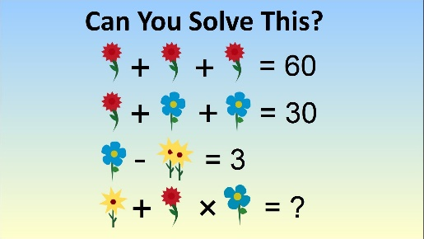
This week is Maths Week. The children will have great fun completing puzzles, solving problems and discovering our Maths trails.

