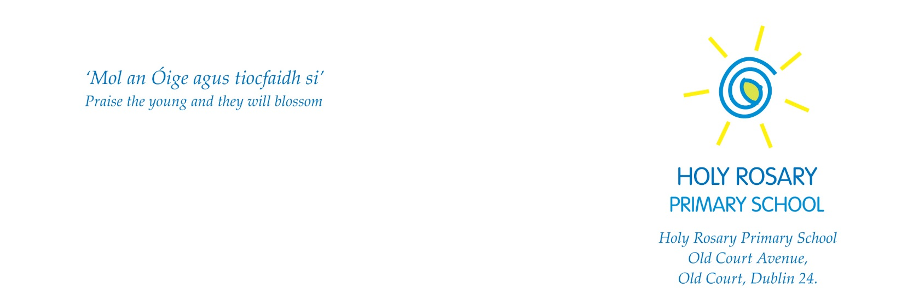

Caretaker

Title of Post: Caretaker
Nature of Position: Fixed Term Contract working as a Caretaker in Holy Rosary Primary School
Reporting to: Principal/Deputy Principal

Summary

Holy Rosary is a modern, large school with over 600 pupils and 50 staff. The school is committed to excellence in all activities and the role of school caretaker is hugely important in ensuring that all school facilities, equipment, buildings and grounds are maintained to a very high standard.
Duties and Responsibilities

Operation and maintenance of electrical, plumbing and security systems. This includes utilising the associated software systems.
- Monitoring efficiency of heating system and ESB meters
- Maintenance and repair of furniture, windows, fixtures and fittings
- Upkeep and renewal of paintwork
- General tidiness of school, disposal of rubbish etc.
- Keep school grounds in good order, grass cutting etc.
- General cleaning and upkeep of school, organising of school cleaners
- Opening and closing of the school
- Ensuring school buildings are safe and secure at all times
- First key holder, attending to alarm call outs
- Making the school safe, particularly during bad weather conditions
- Health and Safety responsibilities
- Strict compliance with School Child Protection Policy
- To keep in a clean condition all glass doors, windows, floors etc.
- To see to the heating requirements of the building and safeguard the heating and water pipes during the cold period of the year
- Other related duties.

Essential Requirements

- Proven experience/ability to undertake caretaking duties
- Experience in grounds keeping (e.g. garden maintenance)
- Understanding/experience in electrics, plumbing and carpentry
- Experience and understanding of Health and Safety issues
- Experience of taking responsibility for the security of a building
- Clean driving licence
- Punctual, reliable and trustworthy
- Ability to work effectively and supportively as a member of the school team
- Good interpersonal and communication skills
- Ability to act on own initiative, dealing with any unexpected problems that arise
- Good organisational and time management skills
- Flexible with the ability to deal with unexpected events and changing work activities
- A willingness to undertake further training and development as required
- A respect for school culture.

Desirable Requirements

- Experience of working in a trade would be an advantage.

General Terms and Conditions of Employment

Hours of work: Caretaker hours of work will be not less than 39 hours per week or equivalent to be delivered in a flexible manner over the year. Hours may be allocated between the hours of 8am and 5pm, Monday to Friday.
Holidays must be taken at times to coincide with school holidays and by prior agreement with management.
Remuneration: The rate of pay is in line with Dept. of Education Caretaker rates and is subject to conditions set out by the Department of Education and Skills from time to time.
Garda Vetting: Employment is subject to Garda Vetting Procedure and Compliance with all appropriate Child Protection and Department of Education and Skills guidelines will be required.

